Perfect skin site

This page will display the products of our website, the page includes **six bar buttons** listed perceptively:

**1-HOME Button:** This will take you back to the home page.

**2- About us Button:** This will take you to the About us page.

**3- GALLARY Button:** This will take you to the GALLERY page.

**4- PRODUCTS Button:** This will take you to the PRODUCTS page (Same page).

**5- CONTACT US Button:** This will take you to the CONTACT US page.

**6- FEEDBACK Button:** This will take you to the FEEDBACK page.

Also, the will page includes the **LOGO** for our website, a **SEARCH** bar that helps the user find what they want faster and easier, a **PHOTO** for each product ( we will have on this page six products ), a **HYPERLINK** for the product name, and product price this hyperlink will take the user to the product website ( For example, If this product is sold at Sephora, the user will be redirected when clicking on this link to the Sephora page). Moreover, this page will include the **COPYRIGHT ICON**, the **website name** in the middle of the page, and the **word “PRODUCTS**” under website name as shown in the provided image.

PAGE 1

Products page

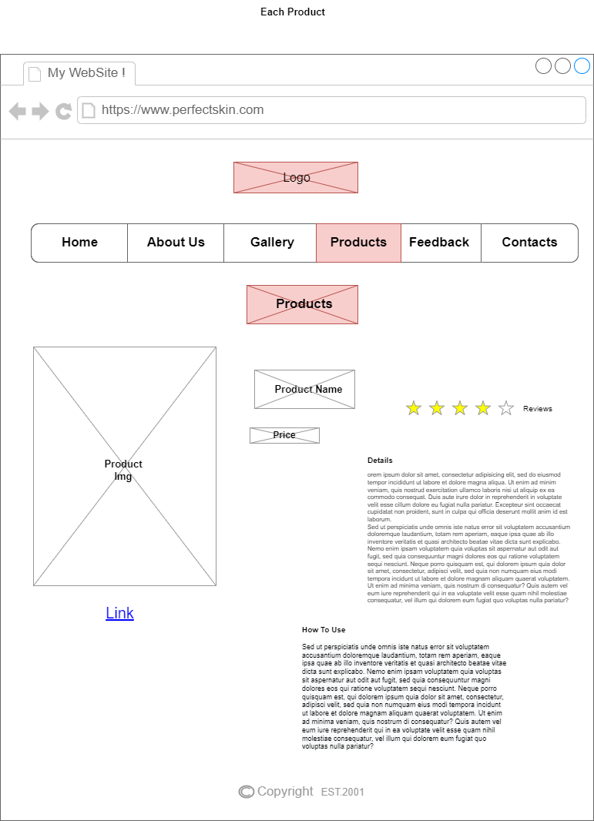

This page will display each product individually, this page includes **six bar buttons** listed perceptively:

**1-HOME Button:** This will take you back to the home page.

**2- About us Button:** This will take you to the About us page.

**3- GALLARY Button:** This will take you to the GALLERY page.

**4- PRODUCTS Button:** This will take you to the PRODUCTS page (Same page).

**5- CONTACT US Button:** This will take you to the CONTACT US page.

**6- FEEDBACK Button:** This will take you to the FEEDBACK page.

Also, the will page includes the **LOGO** for our website, a big size **PHOTO** for the product, the **PRODUCT NAME**, and **PRODUCT PRICE**, and a **HYPERLINK** for the product website ( For example, If this product is sold at Sephora, the user will be redirected when clicking on this link to the Sephora page). Moreover, this page will include the **COPYRIGHT ICON**, the **RATING BAR** which can make the user rate the product, and the **COMMENTS** section which make the user write a comment about the product.

PAGE 2

Products page